# Assessment Task 1 - In-Class Group Workshop Week 3

1. Write pseudocode and develop a program that allows the user to input a set of 5 marks. The program calculates the total and display the grade according to the following information:

|  |  |
| --- | --- |
| Total | Grade |
| 85-100 | High Distinction |
| 75-84 | Distinction |
| 65-74 | Credit |
| 64-50 | Pass |
| 0-49 | Fail |

Ans:

Pseudocode

1. Start
2. Initialize variables:
   * marks: An array to store 5 marks.
   * total: A variable to store the total of all marks.
3. Loop through 5 iterations:
   * Prompt the user to input a mark.
   * Validate the input:
     + Check if the input is a valid number.
     + Check if the number is between 0 and 100.
   * If the input is invalid:
     + Display an error message.
     + Prompt the user to enter the mark again.
   * If the input is valid:
     + Add the mark to total.
     + Determine the grade for the current mark:
       - If mark is between 85 and 100, grade = "High Distinction".
       - If mark is between 75 and 84, grade = "Distinction".
       - If mark is between 65 and 74, grade = "Credit".
       - If mark is between 50 and 64, grade = "Pass".
       - If mark is below 50, grade = "Fail".
     + Display the mark and its grade.
4. Display the total of all marks.
5. End

**Java Program**

/**

*

*/

package Week_3;

import java.util.InputMismatchException;

import java.util.Scanner;

/**

*

*/

public class Grading_1 {

/**

* @param args

*/

public static void main(String[] args) {

// TODO Auto-generated method stub

// Create a Scanner object for user input

Scanner scanner = new Scanner(System.in);

// Initialize variables

int[] marks = new int[5]; // Array to store the marks

int total = 0; // Variable to store the total marks

// Input marks from the user and display individual grades

System.out.println("Enter 5 marks (each mark should be between 0 and 100):");

for (int i = 0; i < marks.length; i++) {

boolean validInput = false;

while (!validInput) {

try {

System.out.print("Mark " + (i + 1) + ": ");

marks[i] = scanner.nextInt();

if (marks[i] < 0 || marks[i] > 100) {

System.out.println("Invalid entry. Please enter a number between 0 and 100.");

} else {

validInput = true;

total += marks[i]; // Add each mark to the total

// Determine the grade for the current mark

String grade = getGrade(marks[i]);

System.out.println("Mark " + (i + 1) + ": " + marks[i] + ", Grade: " + grade);

}

} catch (InputMismatchException e) {

System.out.println("Invalid input. Please enter a valid number.");

scanner.next(); // Clear invalid input

}

}

}

// Display the total of all marks

System.out.println("\nTotal Marks: " + total);

// Close the scanner

scanner.close();

}

// Method to determine the grade based on a mark

public static String getGrade(int mark) {

if (mark >= 85 && mark <= 100) {

return "High Distinction";

} else if (mark >= 75 && mark <= 84) {

return "Distinction";

} else if (mark >= 65 && mark <= 74) {

return "Credit";

} else if (mark >= 50 && mark <= 64) {

return "Pass";

} else {

return "Fail";

}

}

}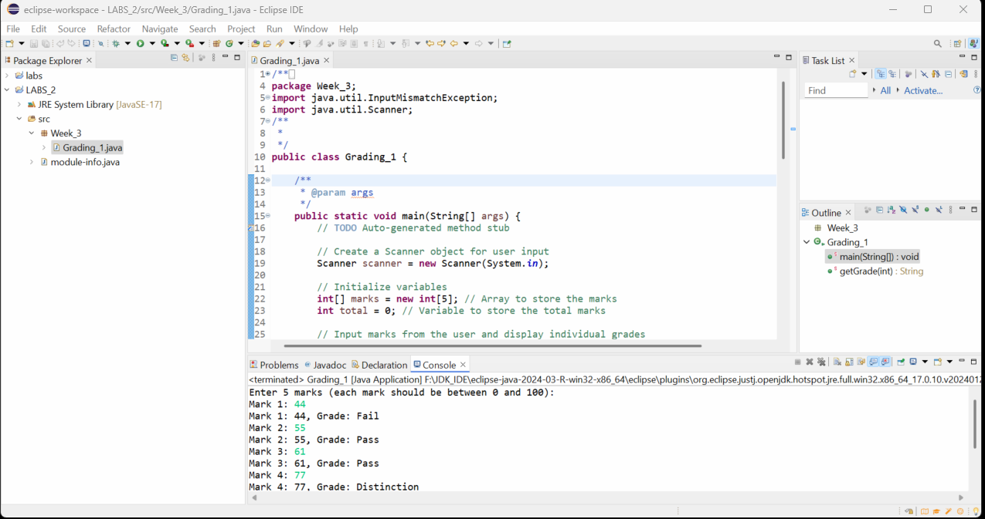

1. Write a program to enter month number. Use switch case structure to print out the name of the month. Also display error message for wrong month number.

Ans:

**package** Week_3;

**import** java.util.InputMismatchException;

**import** java.util.Scanner;

**public** **class** MonthNumber {

**public** **static** **void** main(String[] args) {

// Create a Scanner object for user input

Scanner scanner = **new** Scanner(System.***in***);

**while** (**true**) {

// Prompt the user to enter a month number

System.***out***.print("Enter the month number (1-12) or type 'exit' to quit: ");

**try** {

**if** (scanner.hasNextInt()) {

**int** monthNumber = scanner.nextInt();

// Use switch-case to determine the month name

**switch** (monthNumber) {

**case** 1:

System.***out***.println("January");

**break**;

**case** 2:

System.***out***.println("February");

**break**;

**case** 3:

System.***out***.println("March");

**break**;

**case** 4:

System.***out***.println("April");

**break**;

**case** 5:

System.***out***.println("May");

**break**;

**case** 6:

System.***out***.println("June");

**break**;

**case** 7:

System.***out***.println("July");

**break**;

**case** 8:

System.***out***.println("August");

**break**;

**case** 9:

System.***out***.println("September");

**break**;

**case** 10:

System.***out***.println("October");

**break**;

**case** 11:

System.***out***.println("November");

**break**;

**case** 12:

System.***out***.println("December");

**break**;

**default**:

System.***out***.println("Error: Invalid month number. Please enter a number between 1 and 12.");

}

} **else** {

String input = scanner.next();

**if** (input.equalsIgnoreCase("exit")) {

System.***out***.println("Exiting...");

**break**;

} **else** {

System.***out***.println("Invalid input. Please enter a valid number or type 'exit' to quit.");

}

}

} **catch** (Exception e) {

System.***out***.println("An unexpected error occurred.");

}

}

// Close the scanner

scanner.close();

}

}

